Hockey Ireland User Guide
User Guide for using Field Configurations + Registration Forms

Version 1.0
Table of Contents

1.0 System Structure 3

2.0 Field Configuration 4
2.1 Custom Fields 6

3.0 Creating a Registration Form 7

4.0 Products (Registration Fees) 9

Key Contacts

Hockey Ireland Support
E: EMAIL?@hockey.ie

GameDay Support
E: support@mygameday.app

- System Structure
Important to remember when creating anything from your field configurations, registrations and registration fees is your system set up.
The National Hockey Ireland level has 4 direct sub-organisations which are the provinces.
Beneath each Province is an Association (where Competitions and Members sit), as well as all the Clubs that make up that Province.
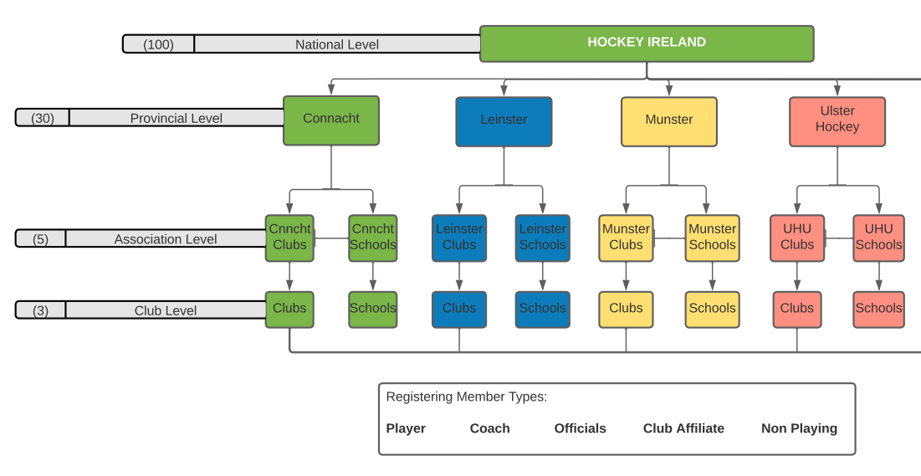
Based on this organisational structure, it is crucial to remember that any rules or settings you apply at one of these levels will syndicate down to levels below it. For example, if you choose to set a field as hidden from the Provincial Level – that will impact all organisations below it in the hierarchy (Associations and Clubs).
This principle is the same for creating Registration Forms and creating Products (Fees).

- Field Configuration
Important Article: https://support.mygameday.app/help/membership---field-configuration
As mentioned in the guide above, field configuration is an important first step when setting up your database. This is where we are setting up what “fields” of information can be collected, stored and visible on Member, Club and Team dashboards across the database.
For Hockey Ireland, the National Level may set specific fields and rules on fields at the top level. Each Province then can add and collect fields specific to them and their area.
Here’s how to do it:
- Log into the GameDay Platform as normal, accessing your main Dashboard
- Go the settings cog on the top right and select Field Configuration
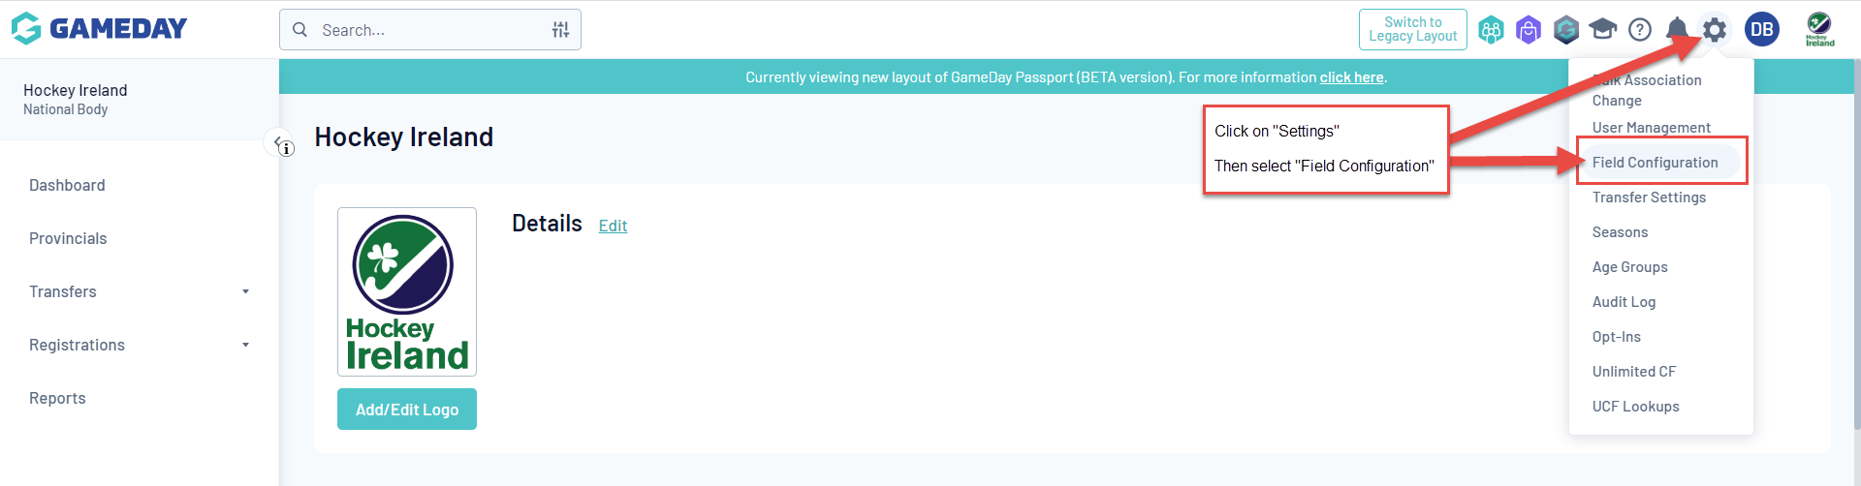
- Notice the tabs for “Members, Clubs and Teams” where you can edit the fields for each within your organisational area. There is a useful option on the right to “Expand All” fields if you need to

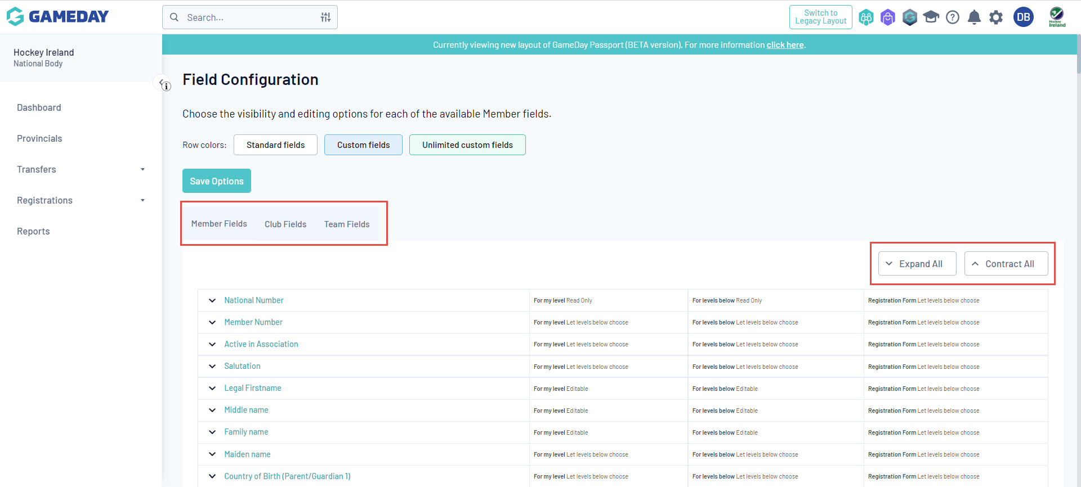

Refer back to the attached FAQ document for more details on changing these fields, and scan through all of the current fields to get used to what is available by default.

Remember these key points.
Field Options:
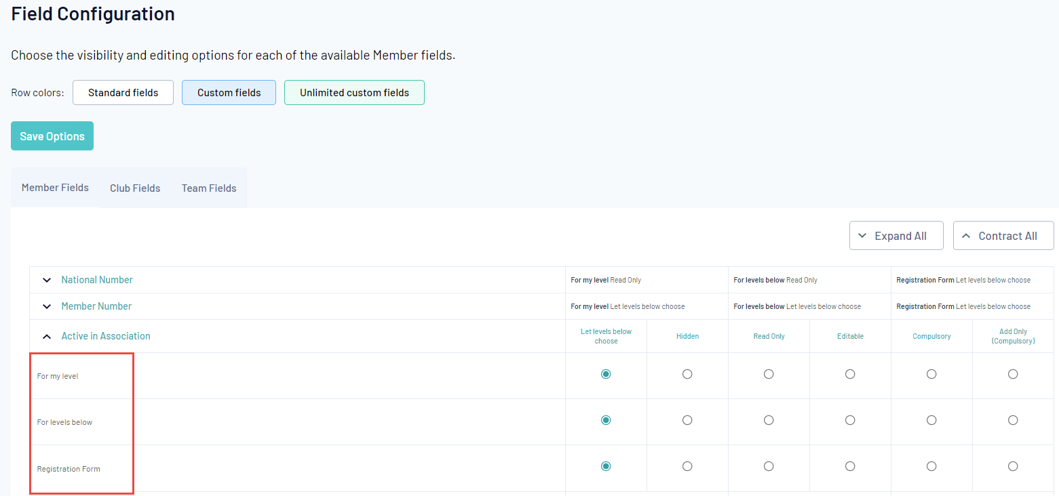
a. For my level: the field setting selected will be applicable to Association administrators. I.e. if you log into the database at the association level, these are the field settings that will apply.
b. For levels below: the field setting selected will be applicable to Club and Team administrators. I.e. if you log into the database at the Club or Team level, these are the field settings that will apply.
c. Registration Form: Please ignore setting fields here, these can be managed when editing your registration forms
Registration Form under Field Configuration:
As a rule, we suggest for Hockey Ireland not to change any field options within this area and registration forms – keeping them all set to “Let Levels Below Choose”. The reason being, you will be creating or editing registration forms and can apply the same rules when setting those forms up separately, editing the fields both here and on your registration forms may create confusion.
Practice editing and enabling some fields, then navigate down that area of the system to find a Member or Club so you can see how your fields have been set.
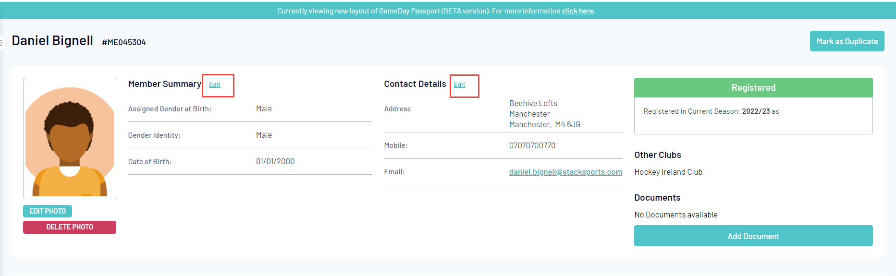
*TIP: Access a player dashboard, and select the “Edit” option to “Show All” fields collected

  - Custom Fields
Important Article - https://support.mygameday.app/help/membership-custom-fields
Although there are a large number of existing fields ready to be used, you may still need to create custom fields of information for your organisation. This might be School information, special category data or marketing and sponsorship information.
- Log in to your dashboard, and hit the settings cog. Then first select “Unlimited CF”
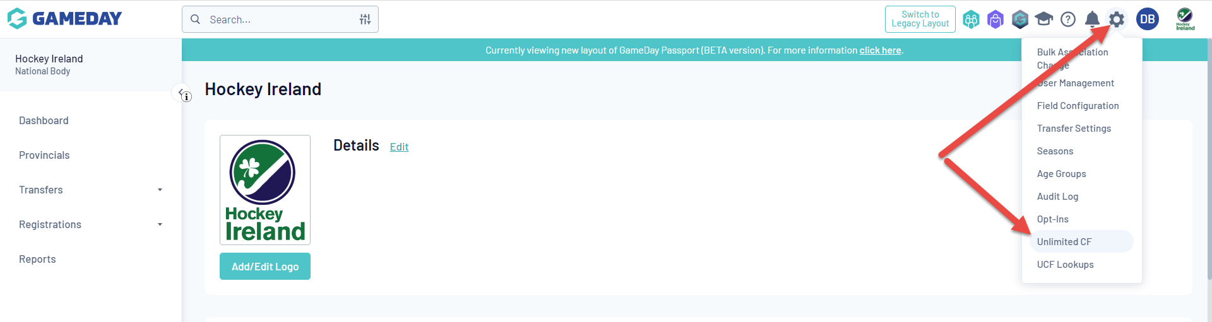

- Create a new one (or Edit an existing one) to build the rules of the field
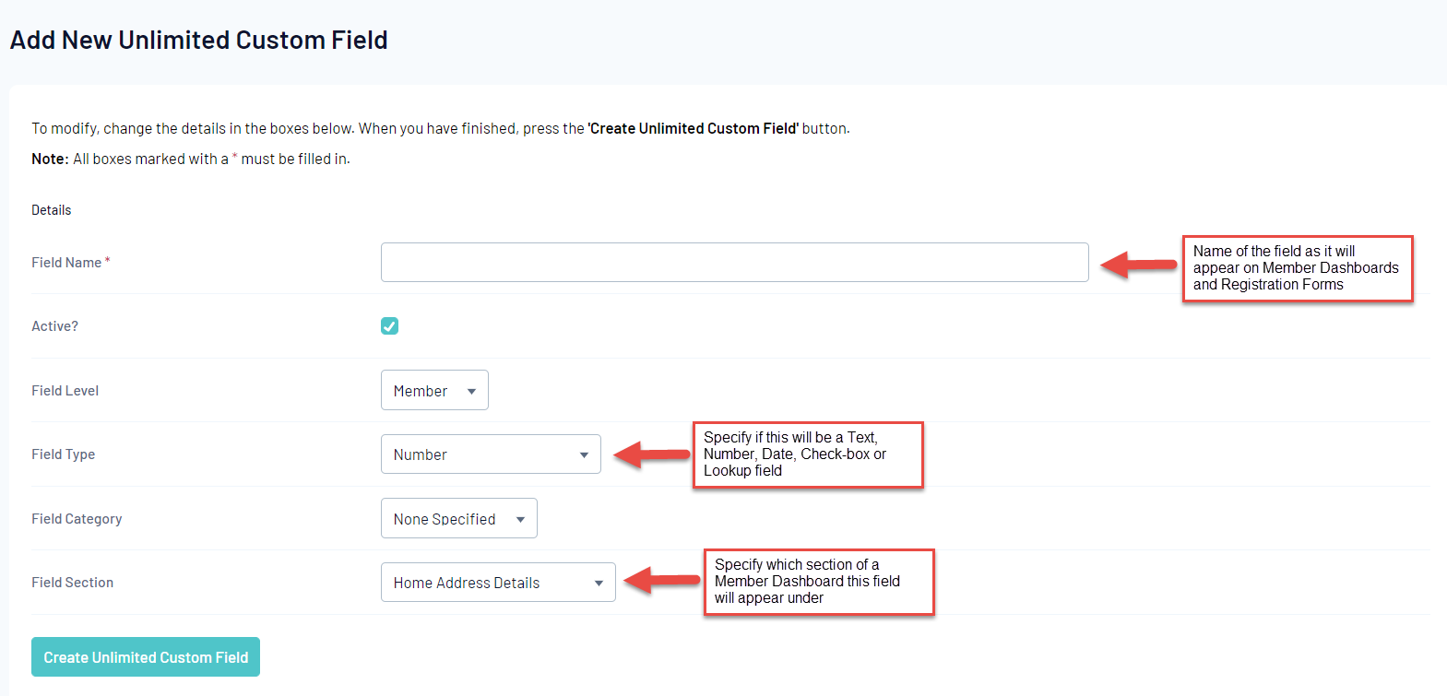
  - If you are creating a “Lookup” field, you will also need to create the lookup options
To do this, go to the settings cog and select “UCF Lookups” – from here you can then add in the dropdown options available for that field you have created

- Once the field is created and saved, it will now be available to add through Field Configuration (Section 2.0) and Registration Forms (Section 3.0)
To add your new custom field through your Field Configuration, simply repeat the first steps in Section 2 above and find the new field

- Creating a Registration Form
Important Articles - https://support.mygameday.app/help/registrations
Registration forms are the basis for all membership registrations, data-collection, and fee purchasing across GameDay.
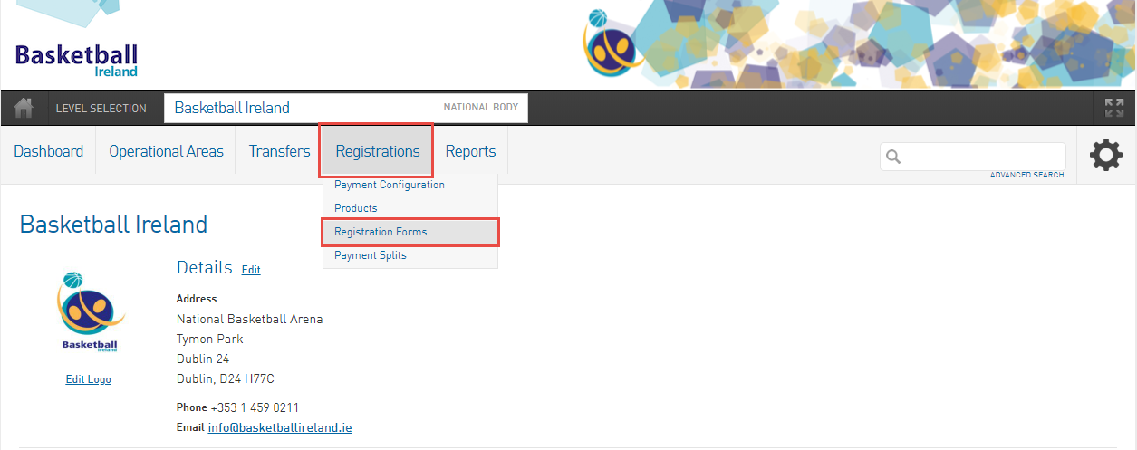*Registration Forms can be found under the Registrations > Registration Forms menu option on your Dashboard
When creating a form, remember which level you are creating it at and where you want it to be available. To re-emphasise the platform structure below:
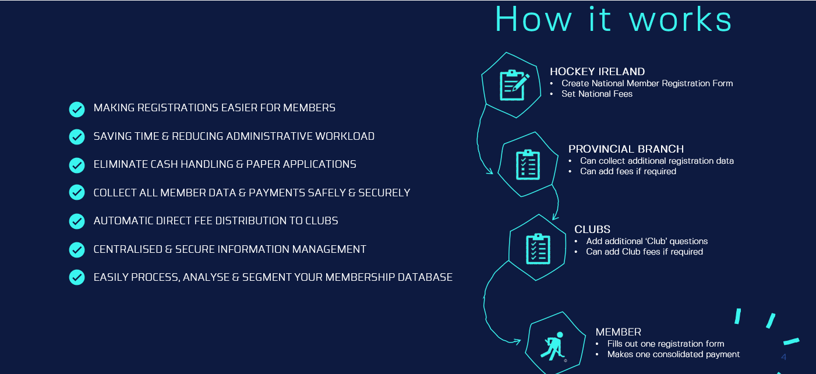

- To create (or edit an existing form) select Registrations followed by Registration Forms
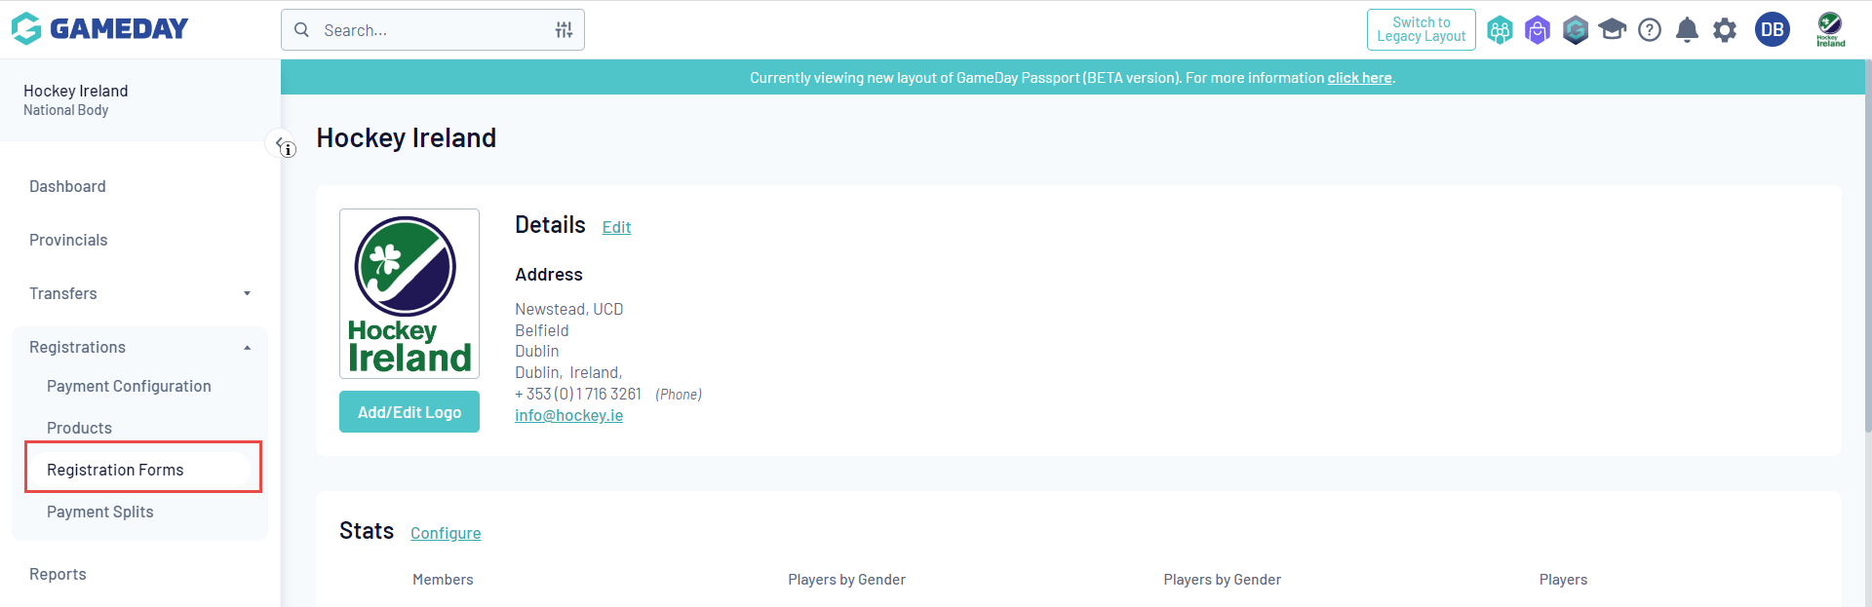
- Your registration forms require the build of 5 Key Areas, and 3 optional areas:
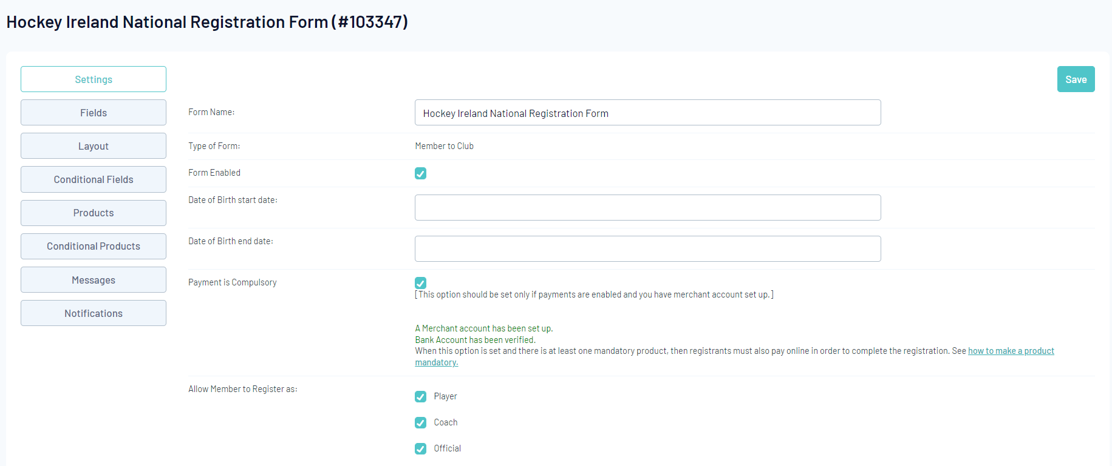
Key Areas:
- Settings – The foundation of the form, who is allowed to register using this form and when is it available
- Fields – Which fields do you want to include on this form which then determines what information is collected (remember this is where field configuration comes in)
- Layout – Alter the layout of the form and fields as they appear, alongside any additional text blocks or header blocks you wish to add on the form too
- Products – This is where we select the registration fees you want to include on the form, products are explained in more detail below
- Messages – Allows you to tailor all of the text and content used within the forms, such as instructions, guidance, welcome messaging, confirmation / rejection emails, etc

Optional Areas:
- Conditional Fields – The same as your regular fields, however these only appear based on rules you make. Such as, one “control” field gets answered in a specific way which then forces an additional question to appear
- Conditional Products – Similar to the above, a “control” field gets answered in a specific way and this then forces a product to appear on the form
- Notifications – This allows you to set across the various organisations in the hierarchy of who will be notified of new registrations and payments, i.e. Club, League, Parents
A more detailed rundown of all of these tabs are available here - https://support.mygameday.app/help/create-a-registration-form

- To test your forms, remember to navigate down to an Association:
Province > Association > Registration Forms
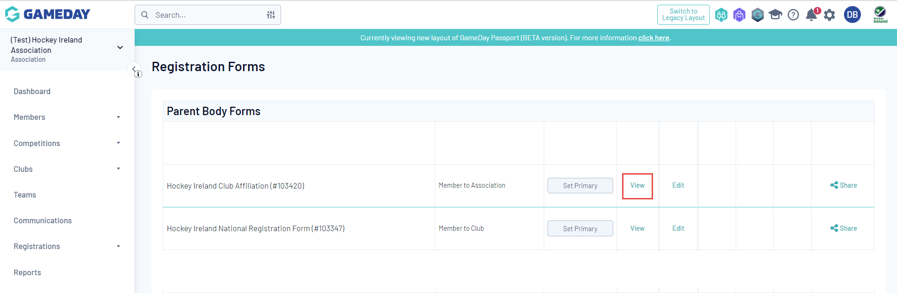

- Products (Registration Fees)
Important Article - https://support.mygameday.app/help/create-a-product
Products are items that can be purchased by members. Examples of products may include registration fees, playing gear or merchandise. Products are closely tied to the Registration Forms, as products are the 'items' that can be added to a registration form to be sold online.
Hockey Ireland will have National Products (Membership Fees) that will be allocated to the primary National Registration form where all Members are expected to register and pay their fees.
Provinces AND Clubs may wish to add their own Products onto the same National Registration form to help centralise the registration process for Members. Allowing them to register to Hockey Ireland, the Province and the Club in one registration.

- Access to Products is found via your Dashboard, click Registrations followed by Products on the drop down
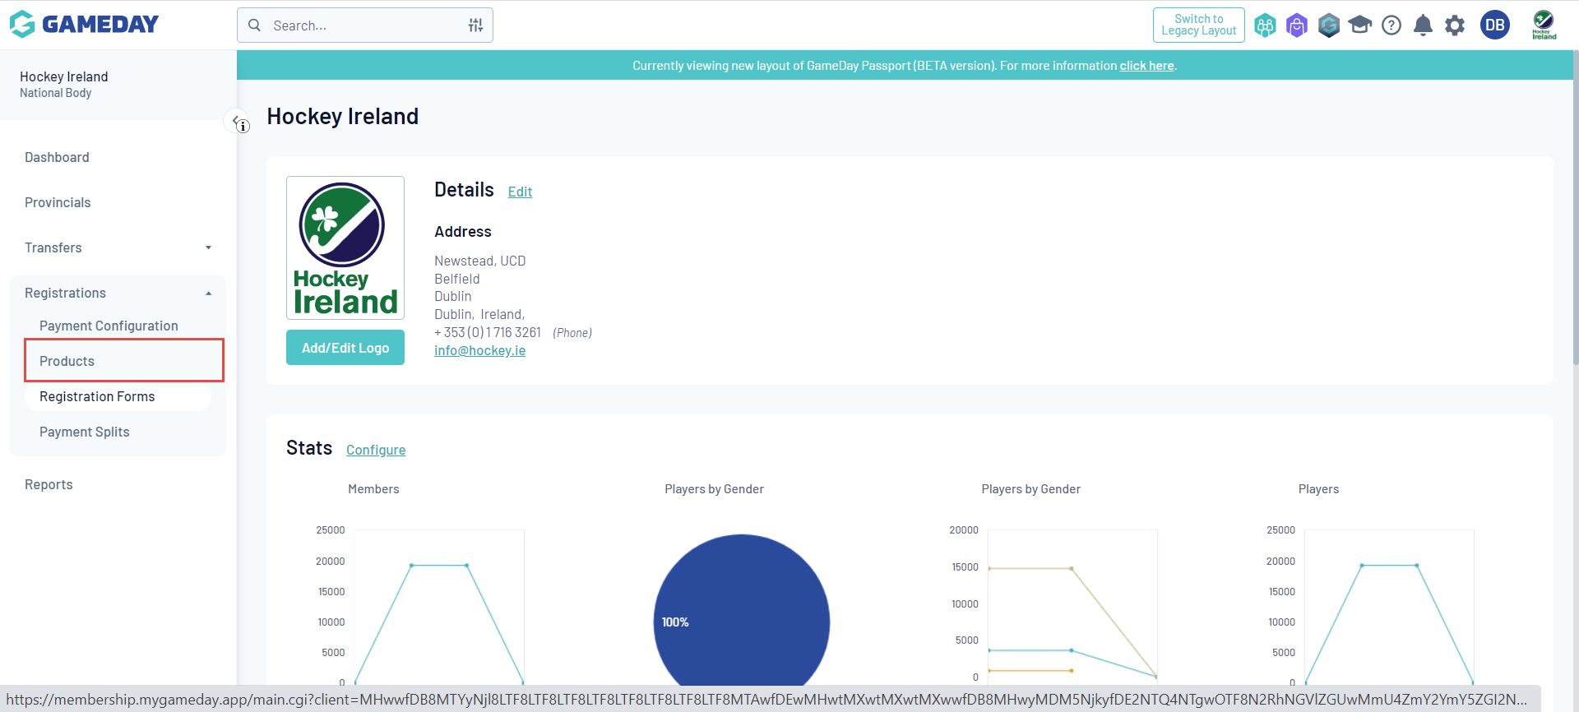
- To create a product, simply select Add New Product or you can Copy an existing one

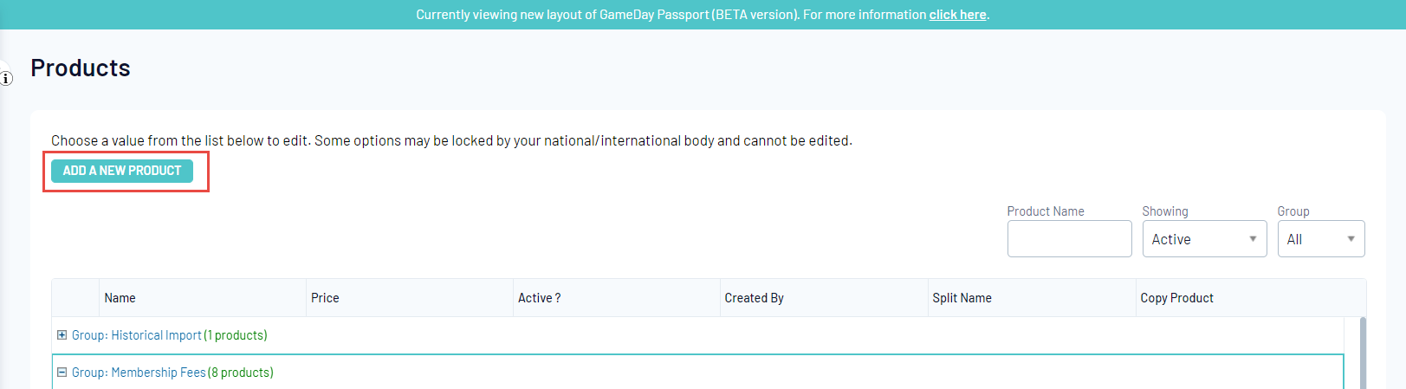

- There are a series of rules and settings you can apply to products when creating them. This includes the pricing, availability and who will be able to view them
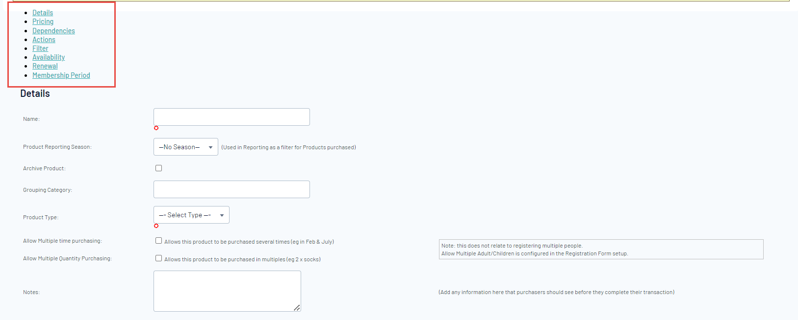
More specific details around each of these tabs can be found on the article: https://support.mygameday.app/help/create-a-product
- Once you have created your Products, remember to add them onto a registration form. To do this, navigate to your registration form, select Edit, and go to the Products Tab
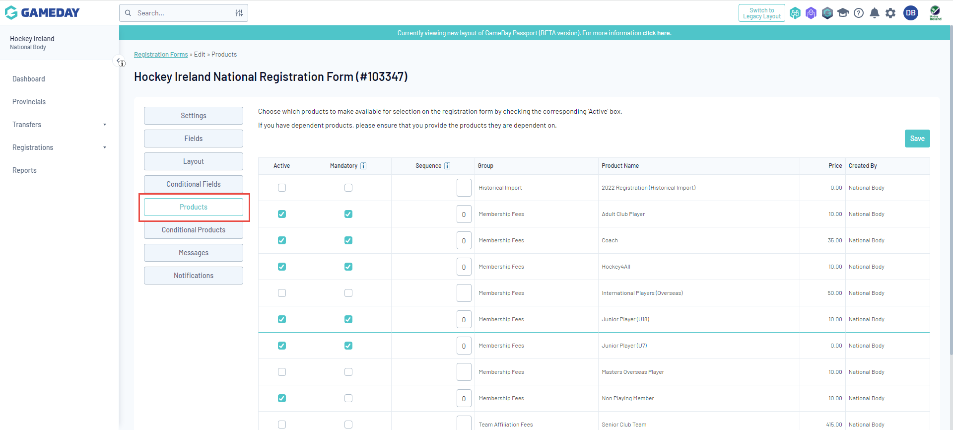

- From this tab, you will see all available Products that can be attached to this form. Note that you can set the following parameters:
Active – Make the product appear on the form (depending on any pre-set filters/rules you have applied to the product itself)
Mandatory – This is a mandatory product that must be purchased before a registration form can be completed
Sequence – What order do you want each product to appear? Applicable if you are displaying multiple products on a form (1 being the highest)

- It is highly recommended that you test your forms and the user behaviours you expect once you have edited and added products to them.

