Hockey Ireland Individual Member

User Guide
User Guide for Members registering to Hockey Ireland

Version 1.0
Table of Contents

1.0 All Registrations 3

2.0 Registering as an individual 5
2.1 Re-Registrations………………………………………………………………………………………………………………5
2.2 New Registrations……………………………………………………………………………………………………………9

3.0 Clubs Registering on behalf of Members…………………………………………………………………….…………13
3.1 Re-Registrations……………………………………………………………………………………………………………13
3.2 New Registrations…………………………………………………………………………………………………………17

Key Contacts

Hockey Ireland Support
E: EMAIL?@Hockey.ie

GameDay Support
E: support@mygameday.app

- All Registrations 2022/23
If you are an individual registering to Hockey Ireland for 2022/23 please read this guide. The first part of the new registration process listed below is applicable to ALL registrations for the season.
Hockey Ireland’s Gameday system requires all members to have an account and member profile attached to that account. In order to register successfully, members will have to complete a form directly to the Province within which they will be registered for the season.
There will be two types of registration for the 2022/23 season on the Gameday system
- Re-Registration; registering for the team you were registered to last season (2021/22)
- New Registration; registering to Hockey Ireland and to a Club for the first time
You will find the registration form link via the Hockey Ireland website here –

The initial process for all RETURNING and NEW Members is the same, please follow the steps below:
- First you must specify how many people you are registering to your account
Parents may wish to include themselves and their children on the same account
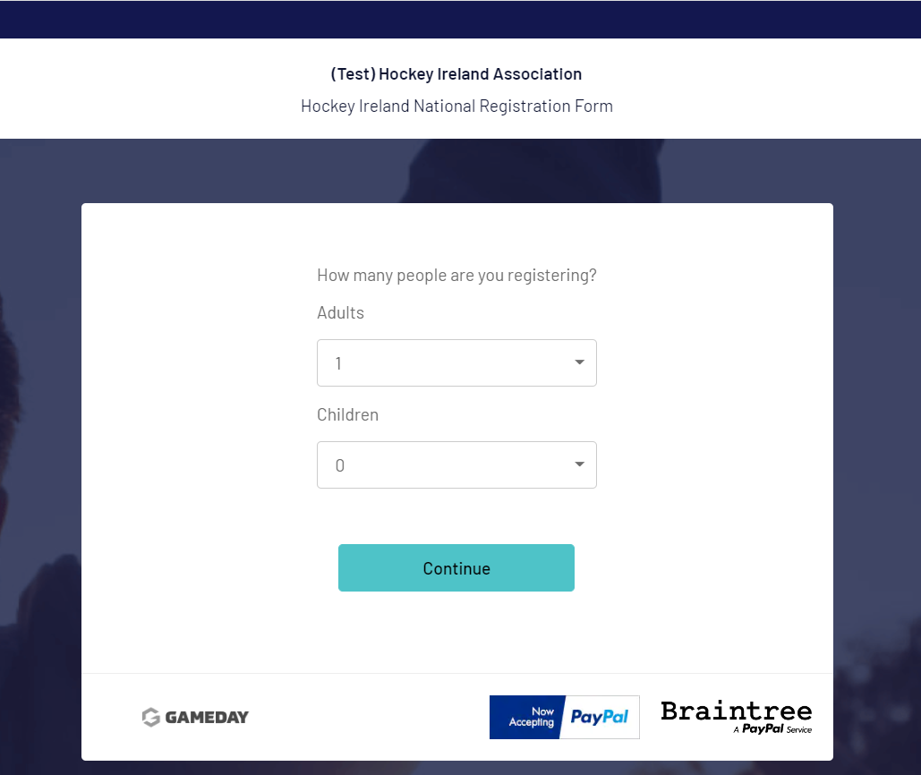

- The next screen will ask you for an email address at the bottom of the page, please use the email address provided to Hockey Ireland last season (2021/22).
Enter your email address and select “Continue”
The system will then ask if you are new, please select to validate your email address and create a new password for your system account.
Following this, you will receive an email from donotreply@mygameday.app asking you to create a new password – make sure you select

- Once you have selectedyou will be taken to a password set screen
Set your Password, followed by Save, then select Continue and you will be automatically re-directed to the registration form
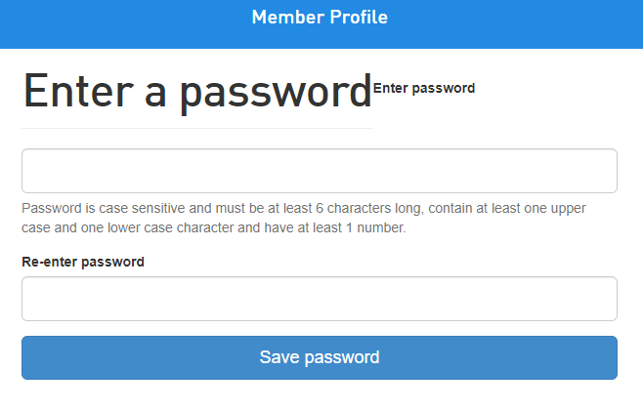

The next steps are different depending on if you are a RETURNING member or a NEW member.
If you are a RETURNING member (registered in 2021/22) please follow section 1.1 below.
If you are an entirely NEW member (not registered in 2021/22), please skip to section 1.2.

- Registering as an individual

  - Re-Registrations
Members who were registered last season on Hockey Ireland’s Go Membership system will have their Name, ME-Number and Email Address carried across with them onto GameDay.
Once you have completed the steps above and now logged into your account, follow these steps:

- Once logged in, if your email address is the same as the one used to register last year you will see your name and ME-Number at the bottom of your screen
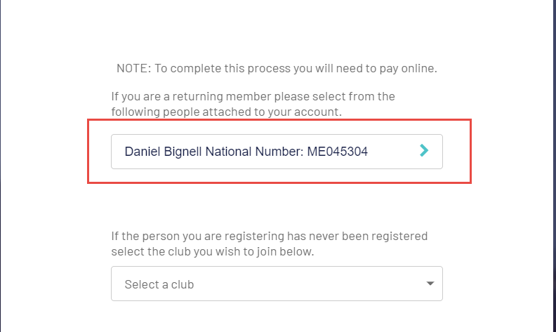
*If your name does not appear, it may mean the email address you provided is not the one on record
In this scenario, either try to start the process again using another email or contact EMAIL?@Hockeyireland.ie to confirm which email address is linked to your member record

- Click your existing Member record and you should then see the Club you were registered to last season. Select this record to progress.
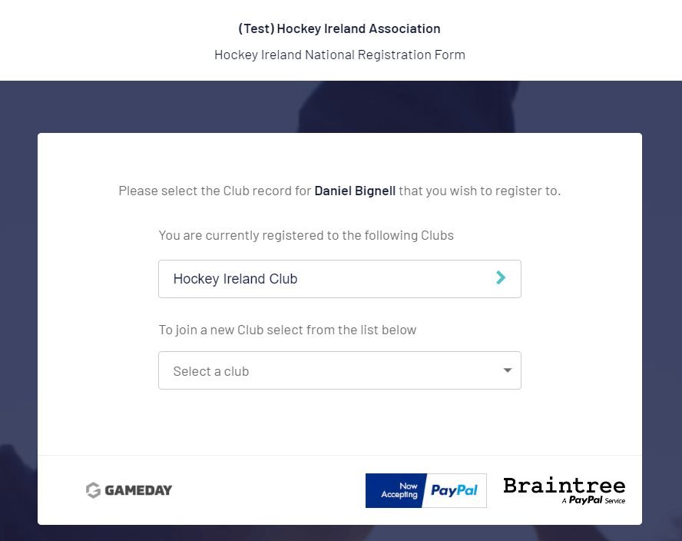
- *If you are registering for a different Club this season, your record will require a Transfer from your previous Club. This means you will still have to register for your old Club before transferring.

- Next, you must define what roles you will be fulfilling this year. If you are registering for multiple member types i.e. Player and Coach, please TICK ALL that apply to you before selecting
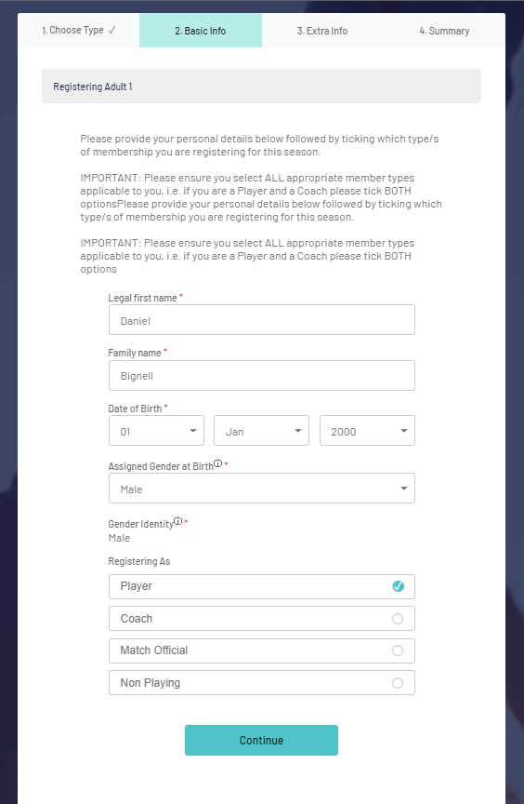

- The next screen will require you to provide registration information to Hockey Ireland.
All fields marked with a red asterisk are mandatory
Fees will appear at the bottom of the form and should automatically show the right fees for you based on what you are registering as this season i.e. Player, Coach, Non-Playing, etc
If the fee you should be paying does not appear, please go back to step 3) and make sure you select the correct member types.

- Once you have completed the form and clicked , you will then be taken to the payment gateway to complete the purchase of your fees.
You will be shown which fees you are due to pay, be sure to click the payment button shown below to complete your payment.
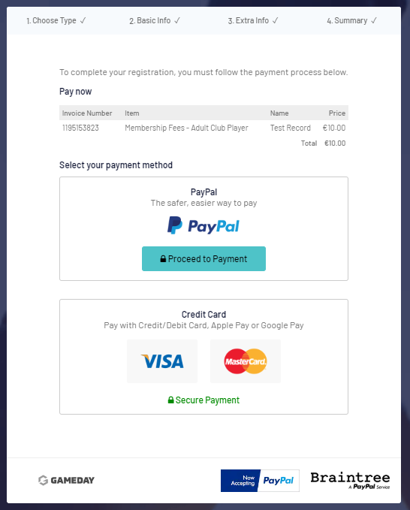

- The payment page will ask for your card details to complete your online payment.
Once entered, select the Pay button to complete the transaction.
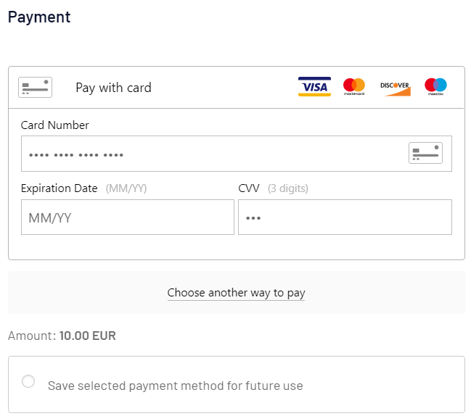
- Finally you will see the Registration Complete page and will shortly receive a confirmation email with your receipt of purchase and confirmation message from Hockey Ireland

2.2 New Registrations
Members who were NOT registered last season will be creating a new Member record and ME-Number. Once you have completed the steps from section 1.0 above and logged into your account, follow these steps:
- Once logged in, you will see instructions laid out and also the “Select Club” dropdown option.
As long as your Club is actively registered you will be able to select the Club you wish to register for from the dropdown.
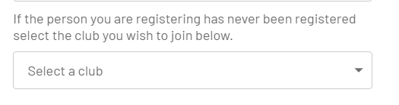

- Next, complete your basic details and then mark which roles you will be fulfilling this year. If you are registering for multiple member types i.e. Player and Coach, please TICK ALL that apply to you before selecting

- The next screen will require you to provide registration information to Hockey Ireland.
All fields marked with a red asterisk are mandatory
Fees will appear at the bottom of the form and should automatically show the right fees for you based on what you are registering as this season i.e. Player, Coach, Non-Playing
If the fee you should be paying does not appear, please go back to step 2) and make sure you select the correct member types.

- Once you have completed the form and clicked , you will then be taken to the payment gateway to complete the purchase of your fees.
You will be shown which fees you are due to pay, be sure to click the payment button shown below to complete your payment.

- Finally, the payment page will ask for your card details to complete your online payment.
Once entered, select the Pay button to complete the transaction.
- Finally you will see the Registration Complete page and will shortly receive an email with your receipt of purchase and a message from Hockey Ireland
Please note that NEW registrations are not automatically confirmed registrations. Your registration will be subject to approval by Hockey Ireland. Once the approvals have been made, you will then receive your confirmation notifications.

