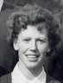
Name: Helen Buckley
International No:
Position: Left Inner/Left Wing
Club(s): Muckross, Ling PEC, Ascot Ladies Berkshire, Ards (Ulster), Umtal Sports Club ( Rhodesia)
Irish Caps: 26
Goals:
Debut: 11th April 1959, V New Zealand (Belfast), W 3-1
Age on debut: 24
Last match: 24th April 1971, V Netherlands (Dublin), L 3-4
Age on last match: 36
Hall of Fame 2007 Inductee
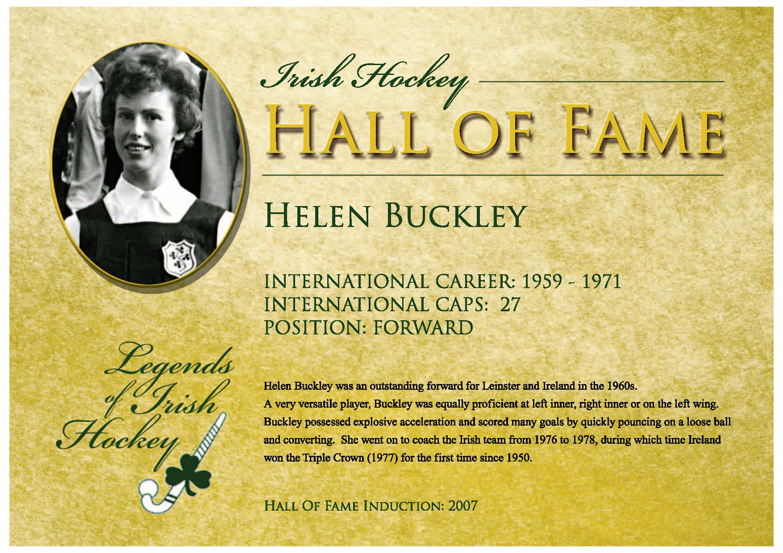
Player Bio
Helen Buckley played her school hockey at Loreto Beaufort. There was an inter schools league between the various Loreto schools with Beaufort winning on several occasions. Helen's highlights were playing every Irish match and in particular playing 2 matches against England at Wembley Stadium in front of 70,000 screaming school children !
There were no interprovincials in Helen's time at underage level. With her club Muckross she won 3 Irish Senior Cups and won both Leinster Cup and League on a few occasions. With Ards she won the Ulster Shield, the Irish Senior Cup and Ulster Cup.
Helen coached Ireland from 1976-1978 with Ireland winning the Triple Crown for the second time in 1977, their first win was in 1950.
Helen was a PE teacher. After her playing career Helen stayed involved in hockey as a club coach with Muckross. She also coached the National team for two years helping Ireland to win the Triple Crown for the second time in 1977. Helen organised a Transition coaching programme for schools in Leinster for 15 years. She was national selector for a number of years and was involved in the coaching administration at provincial and national level
Additional reference sources used:
Literature
Links to Irish Hockey Archives Facebook page:
1959 https://www.facebook.com/1586467858284185/photos/a.1588946741369630/1588948011369503
1960 https://www.facebook.com/1586467858284185/photos/a.1586570998273871/1591197667811204
1961 https://www.facebook.com/permalink.php?story_fbid=2876571069273851&id=1586467858284185
1963 https://www.facebook.com/1586467858284185/photos/a.1588946741369630/1988740131390287
https://www.facebook.com/1586467858284185/photos/a.1787561721508130/2535360230061605
1964 https://www.facebook.com/1586467858284185/photos/a.1586570998273871/2876558435941781
1968 https://www.facebook.com/1586467858284185/photos/a.1588946741369630/1588948238036147
1971 https://www.facebook.com/1586467858284185/photos/a.1586570998273871/2023945437869756
1977 https://www.facebook.com/1586467858284185/photos/a.1586570998273871/1591199554477682
Other online links
https://hockey.ie/information/honorary-life-members/
http://www.newsfour.ie/2022/01/muckross-junior-hockey-club/
http://hookhockey.blogspot.com/2010/04/muckross-iii-hold-twin-division-nine.html
http://www.holychildkilliney.ie/News/Senior-Cup-Champions!/441656/Index.html

