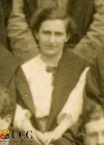
Name: Iris Ashley Cummins
Date of Birth: 06/06/1894
International No:
Position: Half line
Club(s): UCC, Cork
Irish Caps: 31
Goals:
Debut: 9th March 1910, v England (Dublin), L 1-6
Age on debut: 15
Last match: 23rd March 1929, v England (Belfast), L 1-2
Age on last match: 34

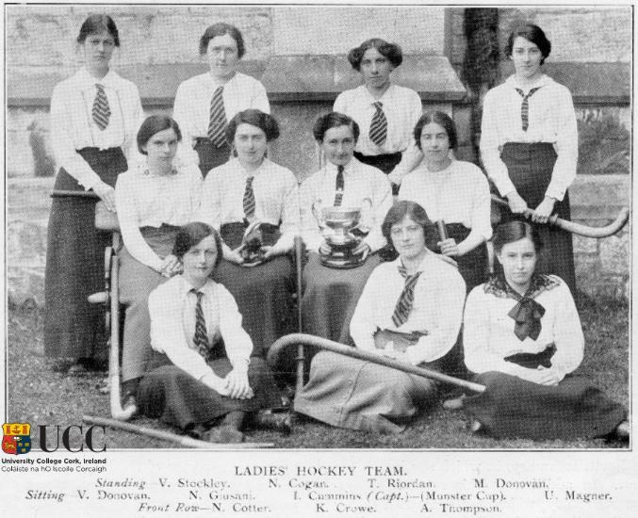
Photo: UCC Official Gazette, Vol. 4 No 12 (June 1914). Iris Cummins, who was the Captain of this team, is holding the Munster Cup.
Club career
Cummins began as a senior player in 1910 with Cork Ladies and in her first season Cummins played on the Munster Interprovincial side. During her time as undergraduate, she played on the UCC Ladies Hockey team. In 1914 she was captain of the team that won the Munster Cup [photo, UCC Official Gazette, Vol. 4 No 12 (June 1914)]. At the end of her international hockey career, she played in goal with Monkstown Hockey Club.
International debut and career: Iris Ashley played 31 times for Ireland with her first and last game against England. As an Irish Hockey International, she captained the team that travelled to USA in 1925. The team visited the White House at the invitation of President Calvin Coolidge.
She was President of the Irish Ladies Hockey Union for the years 1922-23 and 1924-25.
Professional and Personal Bio
Iris was born in Glanmire, Co. Cork and had 10 siblings. In 1915 Iris was the first female to graduate from UCC with a degree in Engineering. She began her own private practice in Cork as a land surveyor in 1924. In 1927, Cummins was appointed first female land surveyor (outdoor staff) for the Irish Land Commission. She retired in 1954. Iris Cummins died on 30 April 1968 at Adelaide Hospital, Dublin, and is buried in the graveyard of St Lappan’s Church, Little Island, Co. Cork, in the same grave as her sister Geraldine Dorothy Cummins. The Iris Ashley Cummins Building (formerly Civil Engineering Building) at UCC was named in her honour on 22 February 2022.
Other family hockey/sports connections: Iris Ashley had 3 other sisters who played for Ireland, Dorothy, Elise and Phyllis.
Additional reference sources used:
Literature
https://www.ucc.ie/en/heritage/historicpeople/alumni/iris-ashley-cummins-be/
Wikipedia: https://en.wikipedia.org/wiki/Iris_Cummins
Links to Irish Hockey Archives Facebook page: https://www.facebook.com/permalink.php?story_fbid=pfbid0jA6owaEtzwbho7WgifX8zhZsrw4J4cYvhy8HXLTzgCLtvgcxYZTdvXyZKSZ3tDeLl&id=1586467858284185

