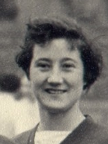
Name: Betty Henderson (Kyle)
International No:
Position: Left Half
Club(s): Owls
Irish Caps: 26
Goals:
Debut: 21st February 1948, v Scotland (Edinburgh) - W 1-0
Age on debut: Years/Days
Last match: 14th March 1959, v Scotland (Belfast) - W 6-2
Age on last match: Years/Days
Hall of Fame Inducted 2006
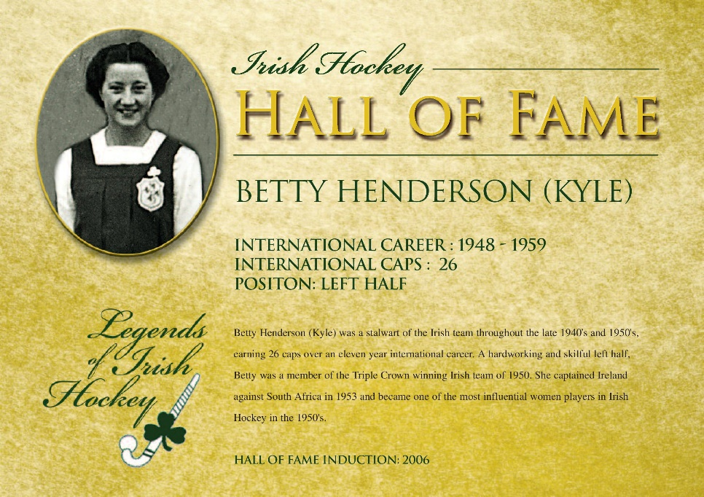
Early career
At the ripe age of thirteen, Betty was drafted on to the Ulster Schools team. At the age of fourteen she became a fully fledged Senior Provincial player. In 1947 after finishing school Betty moved south to Dublin and attended Ling College, a Physical Education College. She played provincial hockey with Leinster during her three years there.
Club career
Betty played with Ling College and on her return to Belfast played with Owls Hockey Club
International debut and career
Betty stepped into the role of left half in 1948 on to the Irish Senior XI. Maintaining her place on the team, Betty was part of the 1950 Triple Crown winning team. Betty captained the Irish team against South Africa at Londonbridge Road in 1953. She played in her last international match in 1959 against Scotland on her home turf in Belfast.
Other Sporting Successes
Betty was an accomplished athlete playing lacrosse, tennis, netball and cricket
Professional and Personal Bio
Betty trained as a Physical Education teacher at Ling College. She was games mistress at Belfast High School
Other family hockey/sports connections
Betty was a member of the well known sporting Kyle family. Jack Kyle played rugby for Ireland in the early 50s and his brother Eric was also accomplished with the oval ball as a scrum half. Maeve married rugby international, Noel Henderson.
Additional reference sources used:
Literature
ILHU, The First Hundred Years, 1894-1994, A Centenary History

Links to Irish Hockey Archives Facebook page:
1953 https://www.facebook.com/1586467858284185/photos/a.1586570998273871/2875176359413322
1953 https://www.facebook.com/1586467858284185/photos/a.1586570998273871/1586574021606902
1956 https://www.facebook.com/1586467858284185/photos/a.1586570998273871/2875176466079978
1956 https://www.facebook.com/1586467858284185/photos/a.1586570998273871/2875895792674712
1956 https://www.facebook.com/1586467858284185/photos/a.1586570998273871/2873981019532856
1958 https://www.facebook.com/permalink.php?story_fbid=2877289222535369&id=1586467858284185
1959 https://www.facebook.com/1586467858284185/photos/a.1586570998273871/2875176386079986
1961 https://www.facebook.com/1586467858284185/photos/a.1679801745617462/2874433276154297

