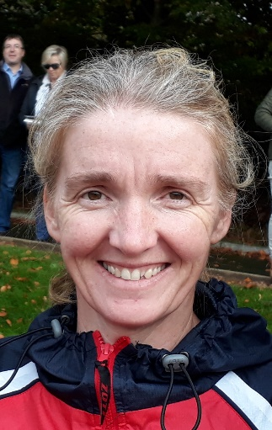
Name: Sharon Hutchinson
International No:
Position: Goalkeeper
Club(s): Catholic Institute, Cork Harlequins, UCC
Irish Caps: 11
GB caps (if applicable):
Goals: 0
Debut: 25 Apr 92 v Scotland (Cork) - L 0-1
Age on debut: 22
Last match: 23 Feb 00 v U.S.A. (San Diego) - D 1-1
Age on last match: 30
Player Bio
Early career: Sharon played her first hockey in Catholic Institute. On moving to Cork when she was 14 Sharon volunteered to go into goal when she started playing with Regina Mundi College. A natural goalie, Sharon went on to represent Munster at U18 and U21 level and succeeded in making the Irish U21s
Club career: Sharon began playing for Cork Harlequins when she was 16 playing on the Minor B1s. On entering UCC in 1988, Sharon became the first team goalie and was part of a very successful UCC team with Sarah Kelleher, Rachael Kohler, Debbie Gaye and Shirine Young as team mates. Sharon returned to play with Cork Harlequins and won an Irish Senior Cup with them in 2000, the first Munster team to bring the cup back to Munster since the 1930s and the first Irish Senior Cup title for the club.
International debut and career: Sharon gained her first cap in 1992 when she played against Scotland in the Home Countries, in her home club Cork Harlequins. Sharon spent much of her time on the bench and was very disappointed not to make the World Cup squad in 1994. Always willing to give it her all Sharon committed to the international scene for 8 years.
Professional and Personal Bio: Sharon is a Ph.D in Chemistry having worked in industry and academia. Sharon currently works as Club Manager of Cork Harlequins. She ran the website, sportswomen.ie, for 3 years and is an accomplished musician playing the piano and clarinet. Sharon is also a Board Member of Hockey Ireland, giving back to the sport she dearly loves !
Other family hockey/sports connections: Sharon’s daughter Saoirse Griffin also won an Irish Senior Cup with Cork Harlequins in 2019, 19 years since the club won their last Irish Senior Cup. Sharon’s son Rory Griffin is also an All Ireland Table Tennis Champion.
Additional reference sources used:
Literature: https://www.irishtimes.com/sport/q-a-sharon-hutchinson-1.2669046
https://www.the42.ie/gender-equality-in-sport-3710817-Nov2017/
https://motley.ie/kings-or-queens-of-sport/
Wikipedia: https://en.wikipedia.org/wiki/Cork_Harlequins
Links to Irish Hockey Archives Facebook page: https://www.facebook.com/1586467858284185/photos/a.1640788569518780/2548903098707318
https://www.facebook.com/1586467858284185/photos/a.1586570998273871/1664801543784149

