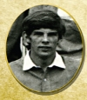
Name: Terry Gregg
International No:
Position: Centre Forward
Club(s): Instonians, Queens University, Belfast YMCA
Irish Caps: 103
Great Britain Caps: 42
Goals: 67
Debut:
Age on debut: Years/Days
Last match:
Age on last match: Years/Days
Hall of Fame Inducted in 2007 link
Player Bio
Early career Gregg first played hockey in school at RBAI (The Royal Belfast Academical Institution). By the time he was 14 it was obvious he was a talent to be reckoned with. He had pace, supreme skill and the confidence of youth to know he could beat any defender.
Club career Gregg played his first club hockey with Instonians 1968-69 and moved to Queens University where he played from 1970-1974, captaining the team in 1972 and winning an Irish Senior Cup with the college side in 1972. After university he played with Belfast YMCA from 1975-1980, winning the Senior Cup in 1977 and 1979.
International debut and career Gregg was capped for Irish Schools and Ulster in 1967-69, he was selected for the British Universities team in 1972-1974. He collected 103 caps for Ireland, scoring 67 goals between 1970 and 1980. Terry captained the Irish side from 1975-79, played in the Intercontinental Cup in 1978, qualifying for the World Cup in 1979 and voted Player and Top Goal scorer of the series. He played in two European Cups, in 1970 and 1978. He collected 17 caps with the Indoor Irish side, followed by 42 caps for Great Britain, of which he was vice captain from 1974-80. The team finished 6th in the 1972 Munich Olympics. He played in the pre Montreal Olympic series in 1976, and Champions Trophy 1978 and 1979. By 1988 he was the most capped Irish or British player and the second Irish men’s player to achieve 100 caps. Gregg’s international career was cut short in 1980 when he was forced to retire with a debilitating viral infection.
Other Sporting Successes Terry represented Northern Ireland at Junior level at Cricket. It took Terry many years to recover from his illness, but he turned his attention towards coaching and got involved with Belfast YMCA indoor team winning every senior trophy from 1980-85 and coaching the team at a European Club Championship. He also coached the outdoor side at the European Club Championships in Barcelona, a turning point for him and on the road to recovery. Terry attained the FIH Coaching Qualification for High Performance.
Terry’s involvement with Lisnagarvey began in 1986 winning 6 Irish Senior cups with the side until 1992. He coached the Irish indoor men’s side from 1983-85 and in 1991 he was asked by the Irish Ladies Hockey Union would he coach the Irish women’s side. He stayed in this role until 1997. He coached the team at a World Cup in 1994 (Dublin), European Cup 1995 (Holland) and a World Cup Qualifier 1997 (Zimbabwe).
Professional and Personal Bio Terry worked as a dentist qualifying as a consultant paediatric surgeon.
Additional reference sources used: 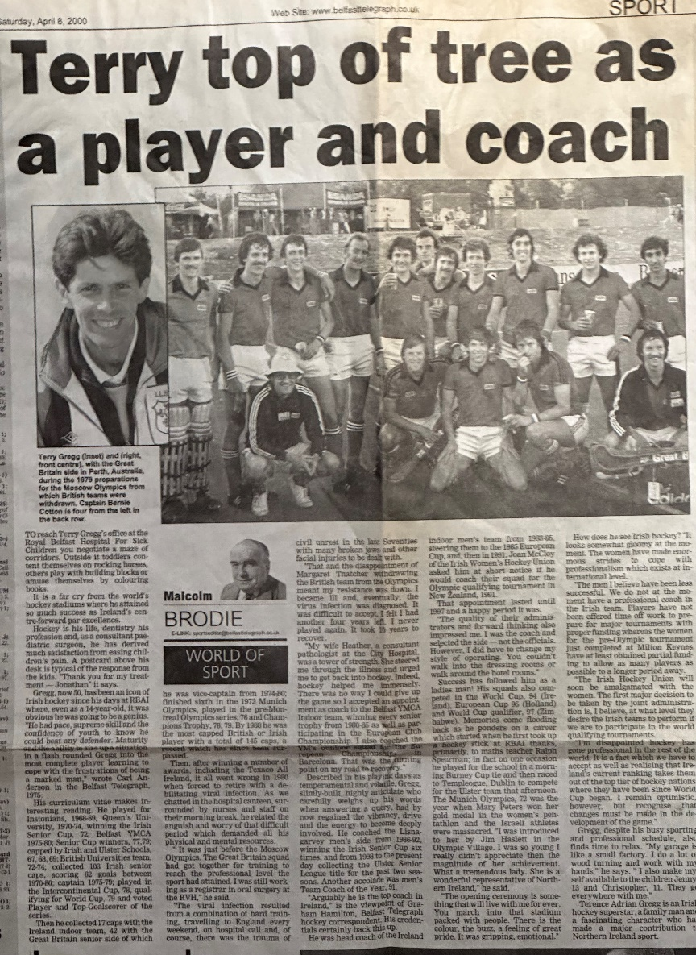
Links to Irish Hockey Archives Facebook page:
https://www.facebook.com/profile/100057181072606/search/?q=terry%20gregg

