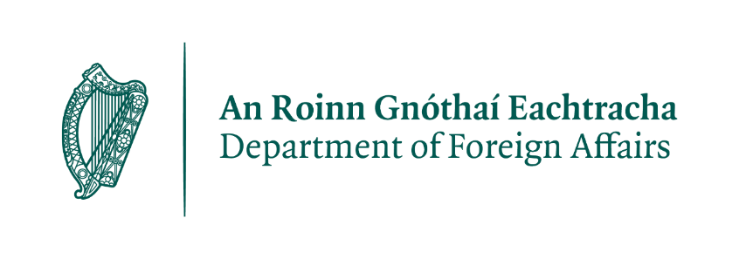
Travel Advice
EuroHockey Championships Mönchengladbach 2023

From 18 to 27 August 2023, Mönchengladbach will host the EuroHockey Championships. If you are planning to travel to Germany for the championships, please Know Before You Go and follow the advice below.

Entry to Germany:

Citizens of Ireland:

There are no visa requirements for Irish passport holders to enter Germany. Irish citizens need a valid passport or passport card to enter Germany, which should be valid for the duration of your stay.

Non-EU/EEA citizens:

Citizens of certain non-EU/EEA countries may require a visa to enter Germany. Please check the website of the German Embassy in Dublin for details on entry requirements for non-EU/EEA citizens: https://dublin.diplo.de/.

Travel and Health Insurance:

DFA strongly recommends that you obtain comprehensive travel insurance, which would cover costs in the event of an emergency, including medical repatriation, repatriation of remains and legal costs. You should check any exclusions and ensure that your policy covers you for activities you wish to undertake.

Make sure to obtain a European Health Insurance Card (EHIC) before you travel to Germany. This card entitles you to emergency medical treatment on the same terms as German nationals. The EHIC is not a substitute for travel insurance and does not cover medical repatriation, ongoing medical treatment for chronic conditions or treatment of a non-urgent nature.

Prescription Medications:

Travellers may bring a 90-day supply of prescription medications for personal use into Germany. Medicines should be carried in their original packaging, with your name, the name of the medication, and the dosage clearly displayed. If your medication contains a controlled substance, such as opioids or stimulants, you should check the specific regulations for bringing these substances into Germany. More info can be found at www.zoll.de

If you have further questions about bringing prescription medication to Germany, you can contact the German Embassy in Dublin.

When in Germany

Personal Identification:

A form of personal ID should be carried at all times when in Germany. Local police have the right to ask for identification at any time, and the only acceptable form of ID for Irish citizens is the Passport Card or full passport. We strongly recommend that you apply for a Passport Card before you visit so that you do not have to carry your passport with you at all times (lost passports account for approximately 90% of emergency assistance cases). It is also a good idea to carry a copy of your passport in case of loss.

Theft/Crime

If you are a victim of a crime while in Germany, report it to the local police by contacting 110. You can also contact the Embassy of Ireland for assistance.

There is a risk of pickpocketing and petty theft in the main German cities, particularly tourist areas. Be careful of your personal belongings.

Medical Emergencies

Numbers for emergency services:
Police 110
Ambulance / Fire Brigade 112

An emergency medical service operates in Germany outside of normal business hours. To locate the nearest clinic operating an emergency service, contact the 24-hour hotline of the German Doctors’ Association on 116 117.

An out-of-hours pharmacy service (“Notapotheken”) operates throughout Germany. Enter the city/post code at the website of the German Association of Pharmacists (www.aponet.de/service/notdienstapotheke-finden ) to locate the nearest pharmacy offering out-of-hours services.

Getting around

Germany has a well-developed network of public transport, and information on the regional public transport network for Mönchengladbach and the region can be found at Homepage | VRR

Driving vehicles, using E-Scooters, or riding a bicycle under the influence of alcohol is illegal and subject to significant fines.

Need our Help?

The Embassy of Ireland can
- Issue emergency travel documents
- Provide support if you have been hospitalised or arrested
- Contact friends or family on your behalf
- Provide a list of English-speaking lawyers

We cannot provide funds or legal advice.

The nearest Honorary Consulate General to Mönchengladbach is in Cologne with the details below:

Ms. Brigitte Wagner-Halswick
Honorary Consulate General of Ireland
Frankenforsterstraße 77
51427 Bergisch Gladbach
Germany
Tel: +49 2204 609 860
Email: brigitte.wagnerhalswick@honoraryconsul.ie
Opening Hours: Monday to Thursday 10:00-14:00

You can reach the Embassy on +49 (0) 30 22 07 20 and follow us for updates on Twitter and Facebook @irlembberlin. If you require emergency assistance outside of working hours, you will be asked to leave a message on the Embassy’s answering machine. The answering machine is monitored regularly, and the Duty Officer at the Embassy in Berlin will contact you as soon as possible.

When you leave a message, remember to state your name, the nature of the problem, where you are now, and the details of how the Duty Officer can contact you.

Embassy of Ireland
Jägerstraße 51
10117 Berlin
berlin@dfa.ie
+49-(0)30-22 07 20

