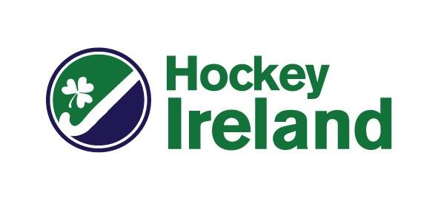

NO OBJECTION CERTIFCATE REQUEST FORM
(From April 2023)

This form is to be completed by a player wishing to receive a No Objection Certificate to play hockey in another FIH affiliated country

- Name of Player
- Date of Birth of Player

- Email Address of Player

- Name of Country where NOC is requested for

- Name of Club in that Country

- Name of previous club in Ireland
- Did you play Hockey for this club in 2022/23? | YES / NO

- If you played hockey for this club in 2022-23 is their consent to you moving to another club attached | YES / NO (if relevant this must be submitted to obtain your NOC)

- Have you played for Ireland at any level, U16s – Seniors, in the past two seasons? | YES / NO (if YES we will need approval from our Performance team to obtain your NOC)

- Dates NOC is required for | FROM - TO -
- Competition/event player will take part in with new club

- Any other information

Please complete and return this proforma by email to Niamh.Fahey@hockey.ie. We aim to process NOC requests within 5 days.

Hockey Ireland
Newstead Block C
Belfield
University College Dublin
Dublin 4

