How to register if you are a new member:

Go to www.hockey.ie/membership and choose your province

When you click on the link to register, you need to put in how many members you are registering.
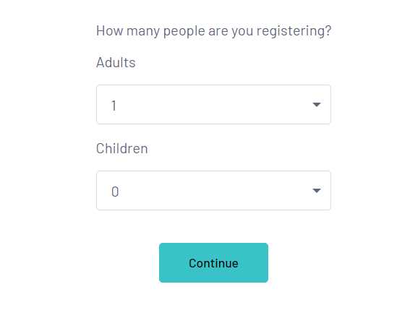
You will be asked to put in your email address.
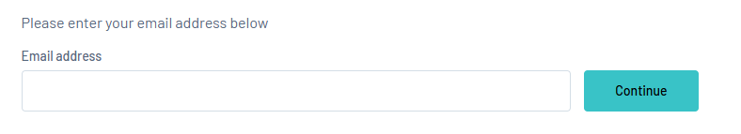
Then your password:
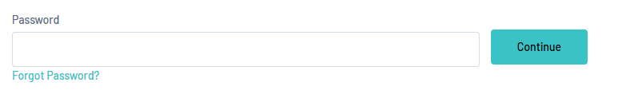

When you put in your password and click Continue you will get the following:
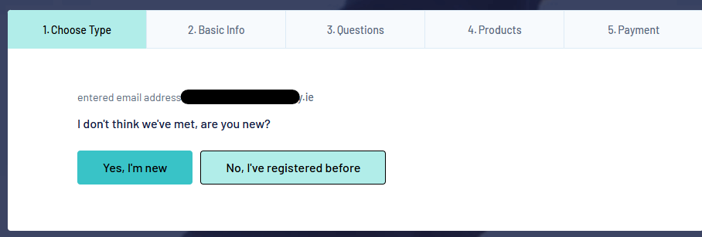
As you have not registered before, you click on Yes, I’m new and you will be sent an email to that email address to set up your password. This might take a few minutes to arrive in your inbox. Check your spam folder also as sometimes it goes in there.
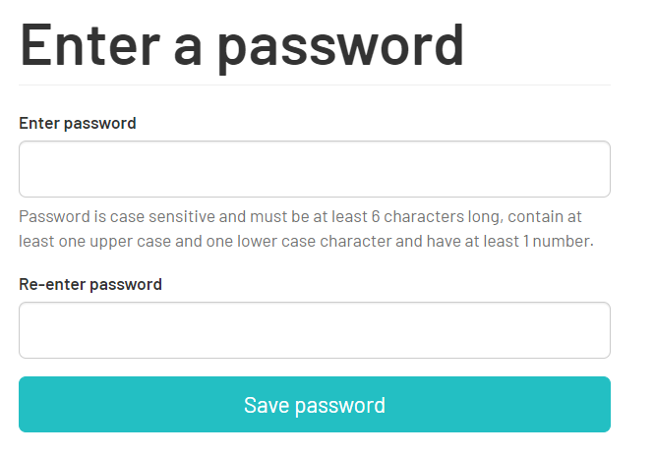

Once you have set up your password, go back to the registration form and sign in.

Once you sign in, you will be asked to select a club you are registering with in the dropdown list.
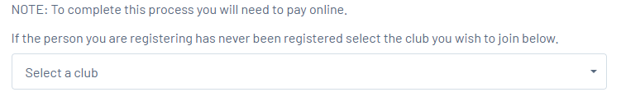
Next, fill in all the info required and on the next page also.
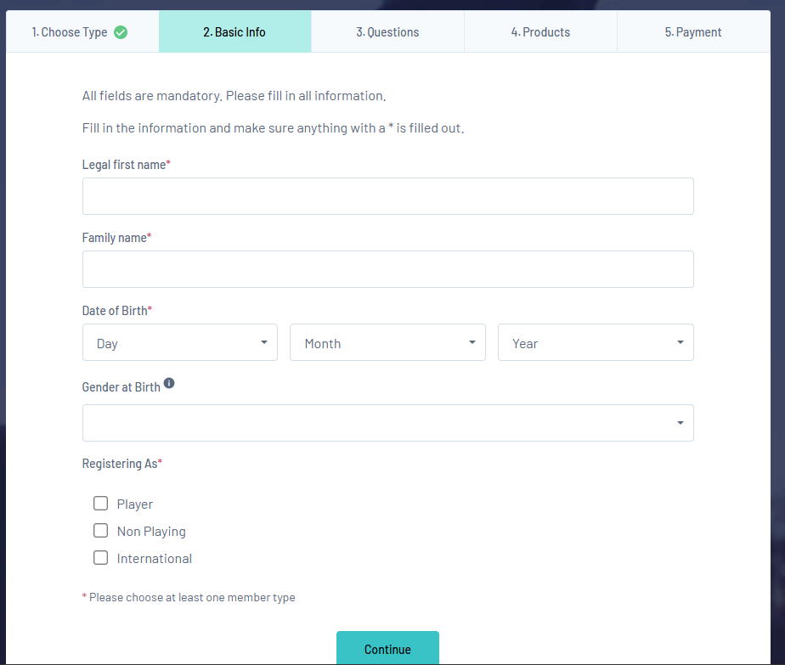

You will then be asked to choose the payment for the person you are registering, whether they are U18 or Senior (over 18)
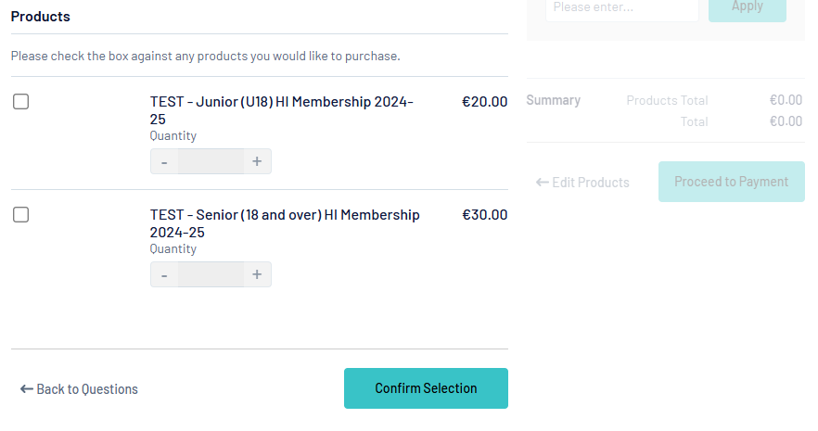

After you tick the membership to pay for, click on Confirm Selection and then Proceed to payment.

If you are registering more than 1 new member, it will bring you to the next registration to fill out and it is the same process to do so.

At the end you can pay for both by either using a card or Stripe.

