How to register on if you are a returning member.

Go to www.hockey.ie/membership and choose your province.

On the first page, please choose how many members you are registering.

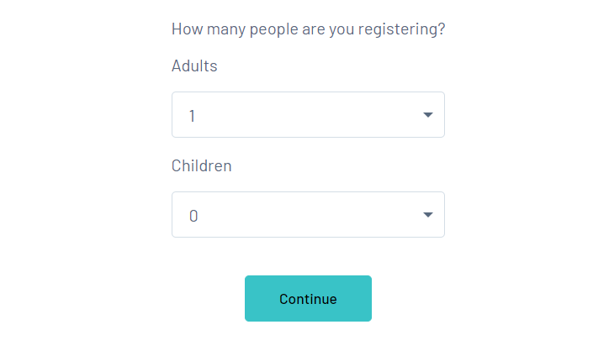

Please enter the email you used last year to sign in.
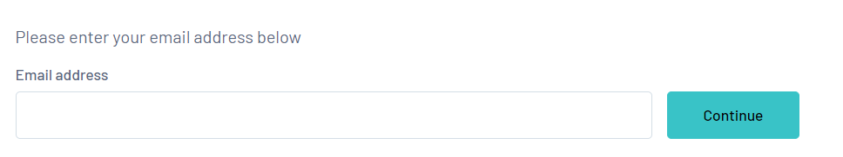
Enter your password. If you forgot it, click on forgot password and you will receive an email to change it. Check your spam folder in case it went in there.

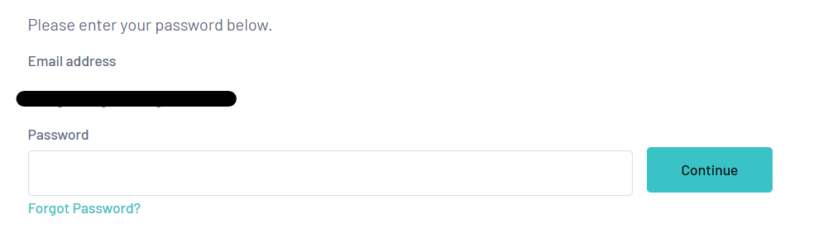

Once you have signed into the correct email address, you will see the ME number/s of registrations you have registered using that email address.

Click on the ME number
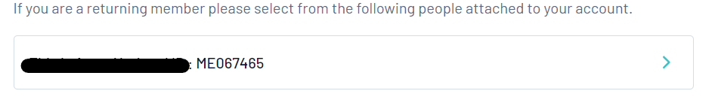

Once you do this, you will see the club you are registering with, if a member last season. Click on the club you are registering with this season. Only choose Club if you are registering as a new member.

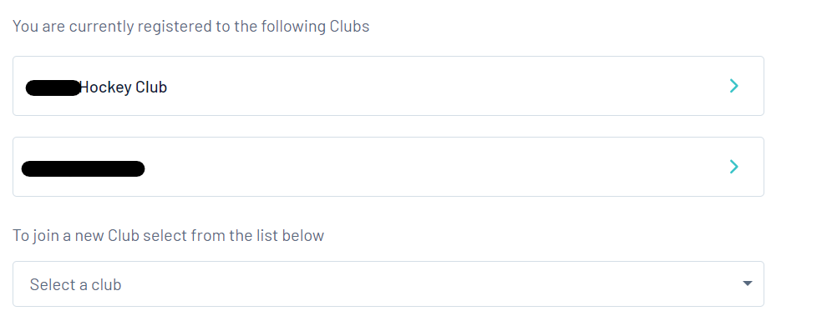

Fill out all the fields and choose what kind of member you will be this season.
Non-playing members include coach, volunteer or umpire.
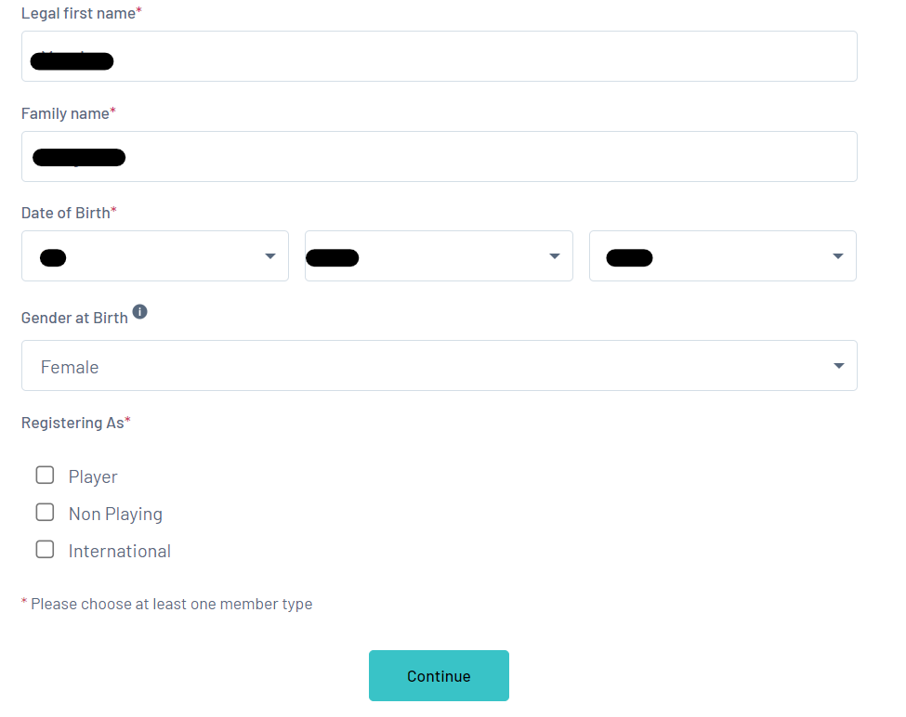
Next screen will ask you to tick what you are paying for and click Confirm Selection, then proceed to payment.
