Step 1: Pay for the Rules of Hockey Test via the following link:
- Choose Type - Online Rules - GameDay Registration

Step 2: Copy and paste the URL into the search bar https://www.sportlearningni.com/product?catalog=1741017505eSxu2

Step 3: Create an account with the Sport Northern Ireland hub, if not done so already.
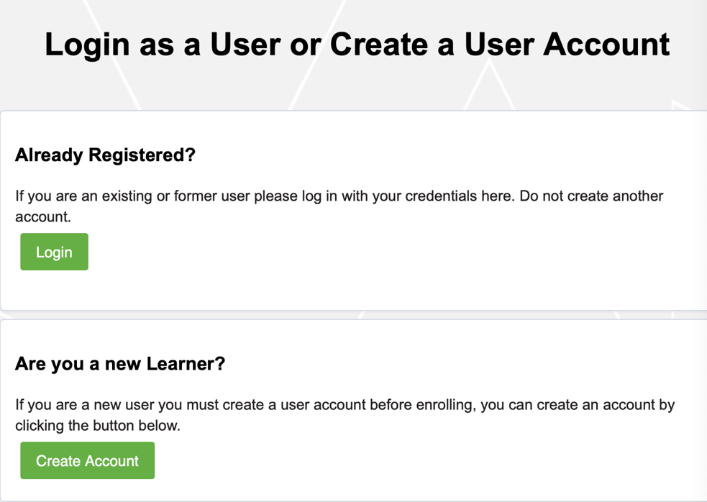

Step 4: Enrol in the Fundamentals of Umpiring course

1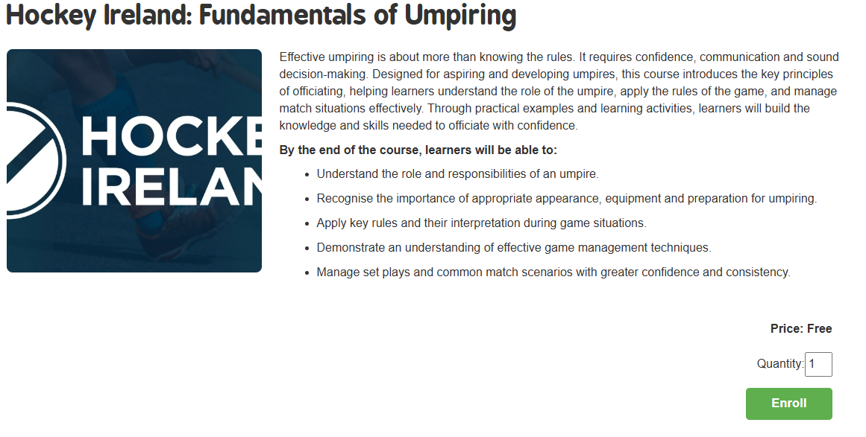

Step 5: Click the green button under Training Access details to access the course on Brightspace

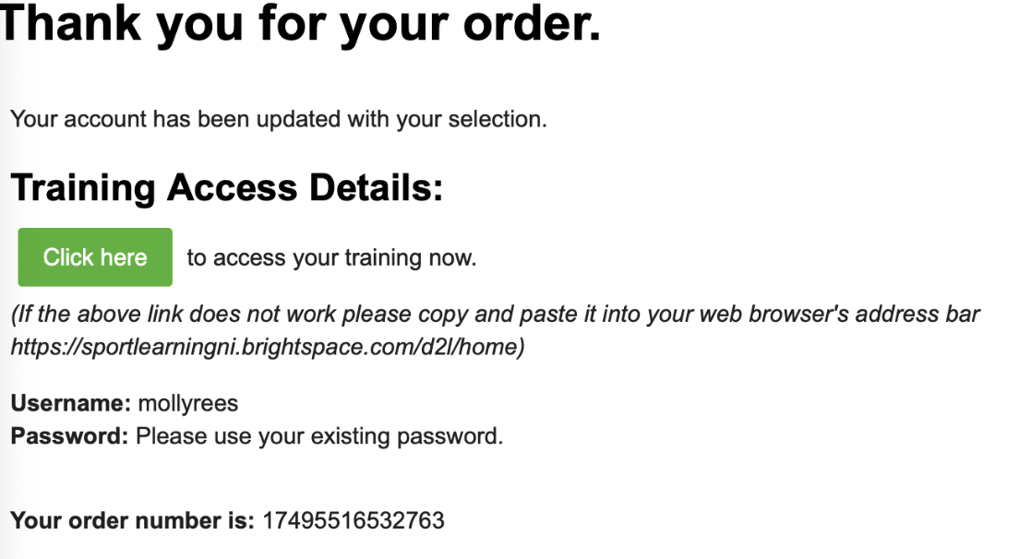

Step 6: Click Hockey Ireland: Fundamentals of Umpiring under ‘My courses’ to start the course

Step 7: Begin the course from ‘Welcome: Quick Guide’ through to the end

Step 8: Once completed, you will receive a certificate of completion under the ‘Awards’ tab

